
Department of Computer Science and IT,
Barani Institute of Management Sciences,
Rawalpindi Pakistan

Real Time Text Extraction and Translation

By

Ahmad Mujtaba 22-ARID-470
Mansoor Shakir 22-ARID-518
Zahid Ahmed 22-ARID-531
Supervisor
Mr. Umair Kazmi
Bachelor of Science in Computer Science (2022-2025)

DECLARATION

We hereby declare that this software, neither whole nor as a part has been copied out from any source. It is further declared that we have developed this software documentation and accompanied report entirely on the basis of our personal efforts. If any part of this project is proved to be copied out from any source or found to be reproduction of some other. We will stand by the consequences. No Portion of the work presented has been submitted of any application for any other degree or qualification of this or any other university or institute of learning.

Ahmad Mujtaba Mansoor Shakir Zahid Ahmed

--------------------------- --------------------------- ---------------------------

CERTIFICATE OF APPROVAL

It is to certify that the final year project of BS (CS) “Real Time Text Extraction and Translation” was developed by “Ahmad Mujtaba, 22-Arid-470”, “Mansoor Shakir, 22-Arid-518” and “Zahid Ahmed, 22-Arid-531” under the supervision of “Mr. Umair Kazmi” and that in their opinion; it is fully adequate, in scope and quality for the degree of Bachelors of Science in Computer Science.

---------------------------------------
Mr. Umair Kazmi
Supervisor

Executive Summary

The project titled "Real-Time Text Extraction and Translation on Android" presents a mobile application designed to bridge language barriers through on-device OCR and translation. Utilizing Google ML Kit for real-time text recognition and MarianMT for multilingual translation, the app allows users to point their camera at any foreign text and receive instant translations without requiring internet connectivity. Built using Jetpack Compose and CameraX, the application emphasizes user privacy, speed, and accessibility, making it especially useful for travelers, students, and individuals with reading disabilities. The solution ensures efficient processing and offline usability by integrating lightweight machine learning models, setting it apart from conventional cloud-based translation services. This project demonstrates how modern Android technologies and edge AI can be combined to deliver a fast, private, and practical real-world solution for language translation.

Acknowledgement

All praise is to Almighty Allah who bestowed upon us a minute portion of His boundless knowledge by virtue of which we were able to accomplish this challenging task.
We are greatly indebted to our project supervisor “Mr. Umair Kazmi” for personal supervision, advice, valuable guidance and completion of this project. We are deeply indebted to him for encouragement and continual help during this work.
We will not be out of place to express my profound admiration for our parents for their continued prayers and support. It was only possible due to their moral support that we continued our education. Many thanks to our colleagues, friends, and cousins who never let us down in hard times.
We always pray for the individuals we mentioned, who helped us to succeed in this and everlasting life. Ameen

Ahmad Mujtaba Mansoor Shakir Zahid Ahmed

--------------------------- --------------------------- ---------------------------

Table of Contents
Chapter 1: Introduction 1
1.1. Brief 1
1.2. Relevance to Course Modules 1
1.3. Project Background 2
1.4. Literature Review 2
1.5. Analysis from Literature Review 3
1.6. Methodology and Software Lifecycle for This Project 3
1.6.1. Rationale behind Selected Methodology 3
1.6.2. Software Development Life Cycle (SDLC) 4
1.6.3. Architecture Overview 5
2.1. Problem Statement 6
2.2. Deliverables and Development Requirements 7
2.3. Current System 8
3.1.1. Use Cases 11
3.2. Functional Requirements 12
3.3. Non-Functional Requirements 12
Chapter 4: Design and Architecture 14
4.1. Entity Relationship Diagram: 14
4.2. Sequence Diagram: 14
4.3. Activity Diagram: 15
4.4. Component Diagram: 16
4.5. State Machine Diagram: 17
4.6. Application Architecture: 18
5.1. Components 19
5.1. Network and Protocol Choice 20
5.2. Choice of Object Middleware 20
5.3. User Interface 20
Chapter 6: Testing and Evaluation 21
6.1. Verification 21
6.2. Validation 21
6.3. Usability Testing 21
6.4. Module / Unit Testing 22
6.5. Integration Testing 22
6.6. System Testing 22
6.7. Acceptance Testing 22
6.8. Stress Testing 23
6.9. Hardware Configuration for Testing 23
6.10. Evaluation 23
6.11. Deployment 23
6.12. Maintenance 24
References 27

List of Figures

Figure 1.1: Block Diagram 8
Figure 2.1: Use Case Diagram 9
Figure 4.1: ERD of app 15
Figure 4.2: Sequence Diagram 16
Figure 4.3: Activity Diagram 17
Figure 4.4: Component Diagram 18
Figure 4.5: State Machine Diagram 18
Figure 4.6: Application Architecture Diagram 19

List of Tables

Table 2.1: Results 9
Table 3.1.1: Use case Table 12

Chapter 1: Introduction
Real-time text extraction and translation is the process of capturing text from the physical world using a camera and converting it into a translated version in the user's preferred language. This technology has wide applications in travel, education, accessibility, and cross-cultural communication. Traditional translation apps often require users to manually input text or rely on server-based processing, leading to privacy concerns and requiring constant internet access. This project addresses these limitations by proposing an Android application that performs on-device Optical Character Recognition (OCR) and instant translation using lightweight machine learning models. By leveraging Google ML Kit and MarianMT, the system captures live text from the camera, translates it in real time, and displays the result over the camera preview, all without internet connectivity. This solution offers a fast, private, and offline-capable tool for breaking language barriers in everyday situations.

Brief
In a globally connected world, the ability to understand and translate text instantly has become a key tool for accessibility and communication. Smartphones, with their camera and processing power, offer a powerful platform to deliver such real-time translation capabilities directly into the hands of users. This project, Real-Time Text Extraction and Translation on Android, aims to solve language barriers by enabling users to extract text from their surroundings using their smartphone camera and translate it instantly into a language of their choice. By integrating OCR (Optical Character Recognition) and on-device translation, this application ensures user privacy, high speed, and offline accessibility. The app is developed using Jetpack Compose for modern and responsive UI, CameraX for handling real-time camera feed, Google ML Kit for text recognition, and MarianMT for translation.

Relevance to Course Modules
This Project is highly relevant to the core modules taught in the BSCS program, such as:
- Artificial Intelligence: Used for real-time OCR and language translation using ML Kit and MarianMT.
- Software Engineering: Requirement gathering, SDLC planning, and modular development structure.
- Machine Learning: Applying pre-trained models for real-world utility.

Project Background
Language barriers pose significant challenges for travelers, immigrants, and individuals accessing foreign content. While several translation apps exist, many require internet connectivity and introduce privacy concerns by sending images to servers. Our project addresses this by implementing an offline-capable, real-time system that recognizes and translates text locally on the device. This empowers users to understand foreign language signs, labels, or documents instantly and privately — without needing to manually type or copy-paste text.

Literature Review
Energy Real-time translation and OCR technologies have evolved significantly in recent years. Various commercial applications, such as Google Translate and Microsoft Translator, provide mobile translation services but often rely on cloud-based solutions. These systems raise privacy concerns, require continuous internet connectivity, and are less efficient in real-time low-bandwidth environments.
Optical Character Recognition (OCR) is a critical step in text extraction from images. Google ML Kit provides robust on-device OCR capabilities, which have been widely adopted in applications requiring speed and privacy. Research shows that on-device OCR can achieve high accuracy and faster performance compared to traditional server-based recognition in mobile apps [1].
MarianMT, an open-source neural machine translation model developed by the Microsoft Translator team, has demonstrated strong performance for multilingual translation tasks. It supports efficient translation between various languages, with the added benefit of being deployable on-device using TensorFlow Lite models. Studies have shown that MarianMT performs comparably to commercial translators when fine-tuned and optimized for mobile environments [2].
Recent work in real-time translation systems has emphasized the importance of low-latency pipelines and intuitive user interfaces. Projects such as Google’s Translation explore direct speech-to-speech translation but require significant resources and infrastructure, making them impractical for lightweight mobile deployments. Our project differs by focusing on text-to-text translation, leveraging efficient on-device models to maintain usability and privacy.
While several academic studies have explored OCR or machine translation in isolation, few have addressed the combination of real-time OCR with translation on mobile devices. This project fills that gap by integrating both technologies into a single, user-friendly Android app that functions offline, prioritizing both performance and user privacy.

Analysis from Literature Review
The literature highlights several key developments in the domains of OCR and machine translation, including the shift toward on-device processing, real-time inference, and lightweight neural models optimized for mobile environments. Most existing solutions emphasize cloud-based translation services and server-side OCR, which, while powerful, are unsuitable for privacy-sensitive and offline use cases. Research into tools like Google ML Kit has shown high accuracy in on-device text recognition, particularly for printed text under good lighting conditions. Similarly, MarianMT has been identified as a high-performing multilingual model with the potential for efficient on-device deployment after quantization and optimization.
Our project differentiates itself by integrating these two technologies—OCR and neural translation—into a single, self-contained Android application that operates fully offline. While prior work focuses on either text recognition or translation separately, our solution combines both in real-time using edge AI. Additionally, the app overlays translated text directly onto the live camera preview, a feature not commonly addressed in academic implementations but widely desired in real-world use.
Therefore, this project builds upon existing research in OCR and machine translation but goes further by implementing a privacy-respecting, offline-capable, and real-time mobile system. This makes it highly applicable in contexts where internet access is limited, such as travel, education, and assistive technology for users with language or reading barriers.

Methodology and Software Lifecycle for This Project

To develop a robust and user-centric mobile application for real-time text extraction and translation, the Agile methodology was adopted. Agile's iterative and incremental approach enables rapid prototyping, continuous user feedback, and adaptability to change — all of which are essential in developing mobile applications involving real-time camera integration and machine learning.
    - Rationale behind Selected Methodology

Agile was chosen because the project involved experimentation with, OCR model configurations, Translation model tuning, Camera integration and UI refinement. With Agile, each development sprint focused on a specific module such as text recognition, translation pipeline, or user interface allowing rapid testing, bug fixing, and integration. This reduced risk and improved quality over time.

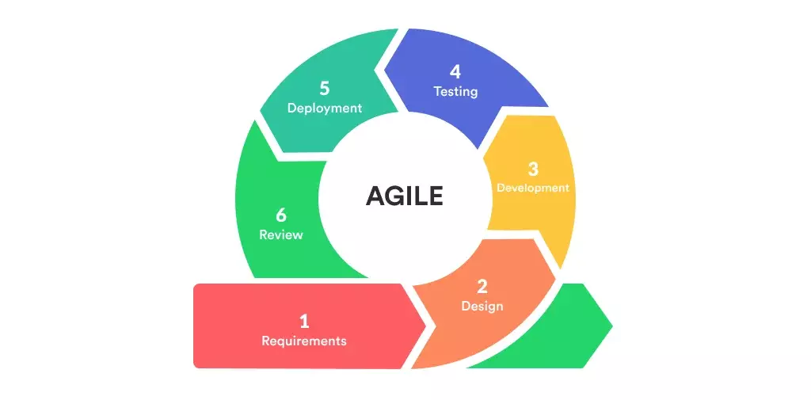

Figure 1.1: Agile Methodology Life Cycle

    - Software Development Life Cycle (SDLC)

The SDLC for this project follows Agile Scrum, involving:
- Requirement Analysis: Understanding user needs, selecting tools (ML Kit, MarianMT, CameraX, etc.)
- Design & Prototyping: UI design using Jetpack Compose; architecture for modular integration.
- Implementation: Developing the OCR, translation, and UI modules incrementally
- Testing: Unit testing, UI testing, performance validation on various devices.
- Deployment: APK build and optional Play Store release
- Maintenance: Optimization for performance and translation accuracy
    - Architecture Overview
The app architecture is modular and layered, consisting of:

- Presentation Layer: Jetpack Compose screens, user interactions.
- Camera Layer: CameraX preview stream and image capture
- Text Detection Module: Google ML Kit OCR processor
- Translation Module: MarianMT-based on-device translation
- Result Layer: UI overlay with recognized and translated text

A clean MVVM (Model-View-ViewModel) structure is maintained for maintainability and separation of concerns.
Chapter 2: Problem Definition
Most modern translation and text recognition applications rely heavily on cloud-based infrastructure, requiring constant internet access and often transmitting user data to remote servers. While these systems provide accurate results, they compromise on privacy, increase latency, and become unusable in offline scenarios—making them unsuitable for travelers, individuals in remote areas, and users concerned with data confidentiality. Furthermore, the process of switching between multiple apps to capture, recognize, and translate text is inefficient and not user-friendly, especially for those who need quick, on-the-go results.
Another critical gap in existing solutions is the lack of accessibility features for individuals with visual or cognitive impairments. Many translation tools are not designed with accessibility in mind and fail to support real-time, readable outputs tailored to assist users who struggle with reading or comprehending foreign languages. There is a need for a solution that not only performs real-time OCR and translation but also presents the results in a way that is easily perceivable and usable for disabled users.
This project addresses these challenges by proposing a mobile application that performs on-device text recognition and multilingual translation in real time, entirely offline, and includes accessibility-focused features such as large text overlays and voice output (in future versions). By integrating these capabilities into a single Android application, the solution empowers users of all backgrounds including those with disabilities to interact with foreign-language content more independently, efficiently, and securely.

Problem Statement

This project addresses the limitations of current mobile translation technologies, which often rely on internet connectivity, cloud-based processing, and disjointed workflows that compromise privacy and hinder real-time translation in offline or low-connectivity environments. Existing apps also tend to neglect accessibility needs, making them difficult to use for visually impaired or cognitively challenged users due to small text, complex interfaces, and a lack of inclusive features like real-time overlays or voice assistance. To overcome these challenges, the project proposes a unified Android application that captures real-world text via the camera, performs on-device OCR using Google ML Kit, translates the text using a MarianMT-based multilingual model, and presents the results through an offline-capable, accessible, and privacy-focused interface enabling seamless, real-time translation for all users, anytime and anywhere.

Deliverables and Development Requirements

To address the limitations of current translation systems such as dependence on internet connectivity, lack of real-time responsiveness, and absence of accessibility features this project proposes the development of a real-time Android application that performs on-device text extraction and multilingual translation. The system is designed to operate entirely offline, preserve user privacy, and serve a wide range of users, including those with disabilities.

Key Deliverables:
Real-Time Text Extraction and Translation App: An Android application that combines CameraX, Google ML Kit, and MarianMT to recognize and translate text from live camera input. The app is capable of working offline and overlays translated text directly onto the screen.
On-Device OCR Module: Built using Google ML Kit, this module detects and extracts printed text from real-time camera frames with high accuracy and efficiency. It serves as the first step in the translation pipeline.

Offline Translation Module: A multilingual translation engine based on MarianMT, optimized for mobile deployment using TensorFlow Lite. It supports translation between multiple language pairs without requiring internet access.

Accessible UI with Jetpack Compose: A modern and clean user interface built using Jetpack Compose, featuring large text overlays, intuitive language selection, and future support for text-to-speech to aid visually impaired users.

Development Requirements:
Front-End Development: Implemented using Jetpack Compose for building a responsive and adaptive UI. It includes support for real-time overlays, language dropdowns, and minimal navigation for user convenience.

Camera Integration: Utilizes CameraX for accessing live camera feed and analyzing frames in real-time with low latency and high frame rate stability.

Text Recognition (OCR): Leverages Google ML Kit’s on-device TextRecognizer to process frames captured by CameraX and extract readable printed text with bounding box detection.

Translation Engine Integration: Uses a lightweight version of MarianMT, converted into TFLite, to ensure fast and efficient offline translation capabilities.

Accessibility Enhancements: Includes enlarged translated text overlays and plans for integrating speech output in future updates. The app layout is optimized for screen readers and simple touch navigation.

Local Storage (Optional): Uses Room or MMKV to allow users to save translated results for future access or offline history tracking.

Testing and Compatibility: Targeted for Android 8.0 (API 26) and above, tested across mid- to high-end devices to ensure broad usability and consistent performance.

Current System

Current mobile translation applications, such as Google Translate, Microsoft Translator, and iTranslate, primarily rely on cloud-based services for both Optical Character Recognition (OCR) and machine translation. While these systems offer high accuracy and support for multiple languages, they depend heavily on stable internet connectivity and often transmit user-captured images or text to external servers for processing. This raises privacy concerns and limits functionality in offline or low-bandwidth environments [1].
In terms of text recognition, most apps use server-side OCR engines or basic on-device capabilities that are not optimized for real-time performance. Additionally, while solutions like Google Translate do offer a camera-based instant translation mode, it is often restricted to predefined languages, lacks customization, and does not expose any modular interface for app developers or research purposes [2].

Furthermore, accessibility support is minimal in mainstream translation tools. Users with visual impairments or cognitive challenges often find these apps hard to navigate due to complex UI, lack of large or spoken text outputs, and the absence of customization features [3].
From a research perspective, many studies focus on high-resource neural translation models like Transformer, BERT, and mBART, which are computationally intensive and generally hosted in cloud infrastructure [4]. Few academic implementations attempt to deploy these models on-device, and even fewer integrate them with real-time OCR in mobile applications.
Additionally, the separation of OCR and translation into different apps or stages reduces usability. Most existing solutions require users to first scan or capture text, then copy it into a separate app for translation—leading to workflow inefficiencies and a fragmented user experience [5].

To address these limitations, this project introduces a privacy-first, real-time translation solution that combines On-device OCR using Google ML Kit, Offline translation using MarianMT, and a user-friendly Jetpack Compose interface with accessibility support. The app works entirely offline, supports instant overlays of translated text, and is designed with inclusivity in mind, offering a seamless solution that surpasses current system capabilities in responsiveness, privacy, and usability.
Table 2.1: Existing Systems
Existing System | Limitations | Technology
Google Translate (Mobile App) | Requires internet for full functionality limited offline support, privacy concerns. | Cloud-based OCR and NMT APIs
iTranslate | Subscription-based offline features; lacks accessibility options | Cloud OCR + Proprietary MT
PaperScan OCR Apps | OCR only; no translation or real-time preview | Tesseract OCR
Open-Source OCR + Translation | Requires manual integration; no unified UI; poor user experience | Tesseract + MarianMT / Google APIs

Chapter 3: Requirement Analysis
The success of a real-time text extraction and translation application depends heavily on clearly defined functional and non-functional requirements. This chapter outlines the essential software and hardware specifications necessary for developing and running the system effectively. The objective of this project is to enable live text recognition and offline translation on Android devices using on-device machine learning models. By integrating OCR and neural machine translation in a mobile environment, the system aims to deliver fast, private, and accessible language translation for real-world use cases.
The functional requirements focus on critical tasks such as capturing real-time camera input, detecting text through OCR, selecting the target language, translating the extracted text using MarianMT, and displaying results as overlays. Meanwhile, the non-functional requirements address key quality attributes such as performance, responsiveness, offline capability, accessibility, and compatibility across Android devices. Together, these requirements ensure the application provides a seamless, inclusive, and robust user experience in both connected and disconnected environments.
  - Use Cases
The Real-Time Text Extraction and Translation project uses the use case diagram shown in Figure 3.1 to illustrate the primary interactions between the user and the mobile application. It highlights essential functionalities such as launching the camera, detecting text using on-device OCR, selecting the desired language, translating the extracted content using an embedded MarianMT model, and displaying the results as overlays on the screen. Additionally, the system offers an optional feature to save translated text for future reference. This diagram provides a clear overview of the application's core functionality and user engagement. It defines how users interact with the system at each step, from capturing the input to receiving a translated output in a fast, seamless, and privacy-focused manner. The use case model supports the planning and development of a user-centric application that prioritizes efficiency, accessibility, and offline operability.

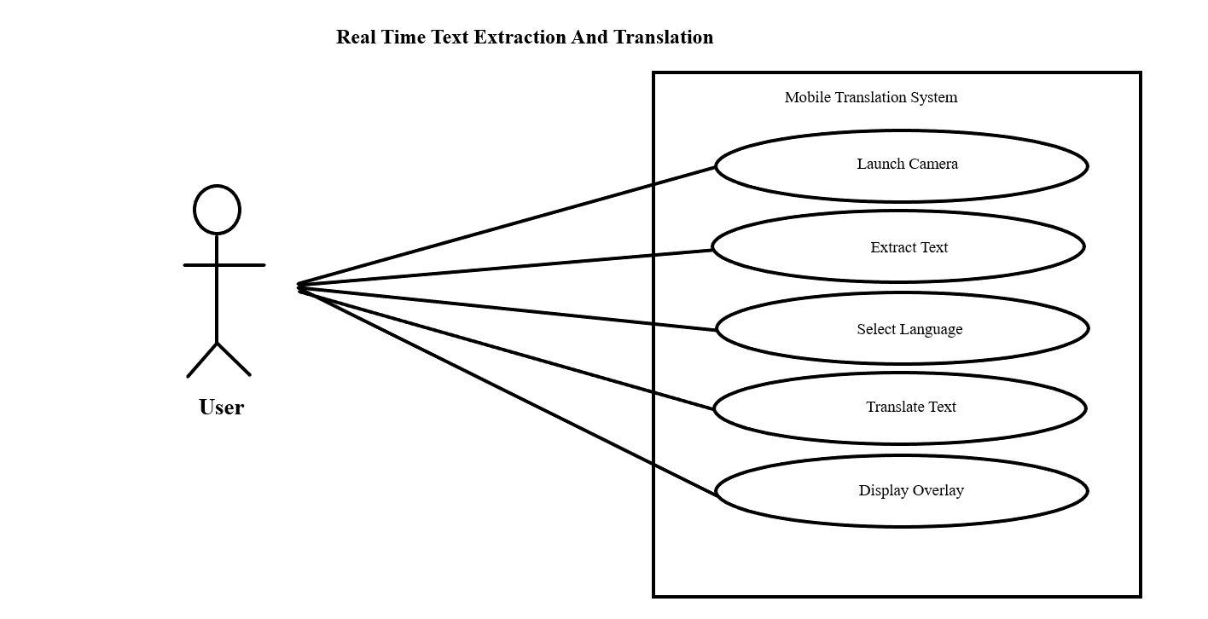
Figure 3.1: Use Case Diagram Real Time Text Extraction and Translation

3.1.1. Use Cases

Use Case | Actor | Description
Launch Camera | User | Starts the live camera feed using the device's camera via CameraX.
Extract Text | User | Detects and extracts printed text from camera input using on-device OCR (ML Kit).
Select Language | User | Allows the user to choose the target translation language from a list.
Translate Text | User | Translates the extracted text to the selected language using MarianMT.
Display | User | Shows the original and translated text on the screen over the camera feed.
Table 3.1.1: Use Case Table use case table for real time text extraction and translation.

3.2. Functional Requirements
Functional requirements describe the specific operations and behaviors that the system must perform to meet user and stakeholder needs. They define what the system should do by outlining clear, measurable functionalities such as data input, processing, output, and user interactions. These requirements guide system design, development, and testing, ensuring the system behaves as intended.
FR-3.2.1: Image Capture: The system must allow users to capture real-time images or video frames using the device camera for text extraction.
FR-3.2.2: Text Extraction (OCR): The system must extract text accurately and efficiently from captured images using on-device Optical Character Recognition (OCR).
FR-3.2.3: Text Localization: The system must detect and provide coordinates of text regions within the captured image for highlighting and bounding box visualization.
FR-3.2.4: Text Translation: The system must translate the extracted text from the source language to a target language using an on-device MarianMT translation model.
FR-3.2.5: Real-Time Display: The system must display extracted and translated text dynamically in the app UI, updating as new frames are captured.
FR-3.2.6: User Interface: The system must provide a user-friendly interface using Jetpack Compose that supports language selection, capture control, and viewing extracted/translated text.
FR-3.2.7: Offline Functionality: The system must perform OCR and translation entirely on-device without requiring an active internet connection.

3.3. Non-Functional Requirements
Non-functional requirements describe how the system performs under specific conditions rather than what it does. They cover system attributes such as performance, usability, reliability, and maintainability. These ensure the system functions correctly while being efficient, secure, and user-friendly.

NFR-3.3.1: Performance: The system should process camera frames and perform OCR and translation with minimal latency to enable near real-time feedback.

NFR-3.3.2: Accuracy: The OCR and translation components should achieve high accuracy in text recognition and language translation, minimizing errors in common use cases.

NFR-3.3.3: Resource Efficiency: The system should optimize CPU, memory, and battery usage to run smoothly on typical Android mobile devices without excessive resource consumption.

NFR-3.3.4: Usability: The user interface should be intuitive and accessible, allowing users of varying technical skills to easily operate the app.

NFR-3.3.5: Scalability: The architecture should support adding more languages or advanced OCR models in the future with minimal changes.

NFR-3.3.6: Reliability: The system should handle exceptions and errors gracefully, ensuring stable operation during extended use.

NFR-3.3.7: Maintainability: The codebase should be modular and well-documented to facilitate future updates, debugging, and enhancements.

Chapter 4: Design and Architecture

The Real-Time Text Extraction and Translation System is built as a mobile application with real-time image processing, OCR-based text detection, and on-device neural translation using MarianMT. The architecture is designed to ensure modularity, scalability, and responsiveness, making it suitable for real-time use cases on resource-constrained mobile devices. Each layer is built with a clear separation of concerns, facilitating easy maintenance, testing, and future enhancements.

4.1. Entity Relationship Diagram:
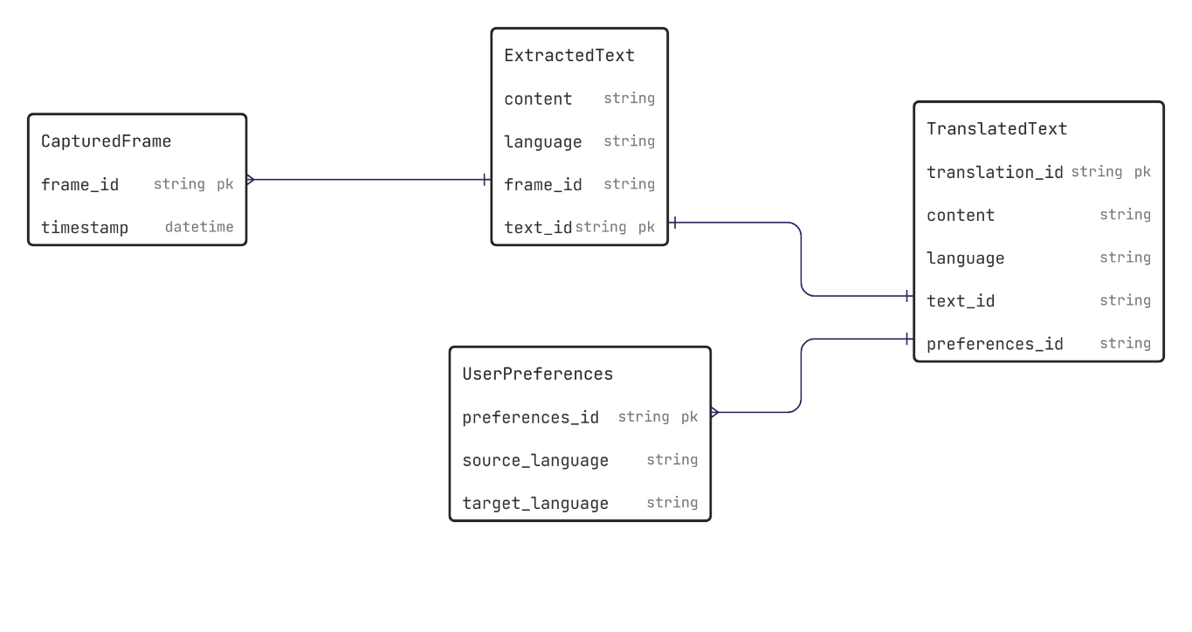 Figure 4.1: ERD Diagram of Real-Time Text extraction and Translation

The Real-Time Text Extraction and Translation app uses the Entity-Relationship Diagram (ERD) shown in Figure 4.1 to represent the internal data model used within the application. The system maintains core entities such as CapturedFrame, ExtractedText, TranslatedText, and UserPreferences. These entities reflect the flow of data from image capture to text recognition and final translation. Relationships are established to track translations corresponding to each captured frame and to store user-selected source and target languages for customized experiences.

4.2. Sequence Diagram:
The system uses the sequence diagram shown in Figure 4.2 to detail interactions among the primary components: the CameraX module, ML Kit OCR, MarianMT Translator, and the Jetpack Compose UI. It outlines the flow from user interaction (camera trigger) to capturing a frame, running OCR to extract text, passing the result to the translation model, and finally rendering the translated output in the UI. The diagram also includes conditional checks for on-device availability and fallback behaviors to ensure smooth user experiences in offline mode.

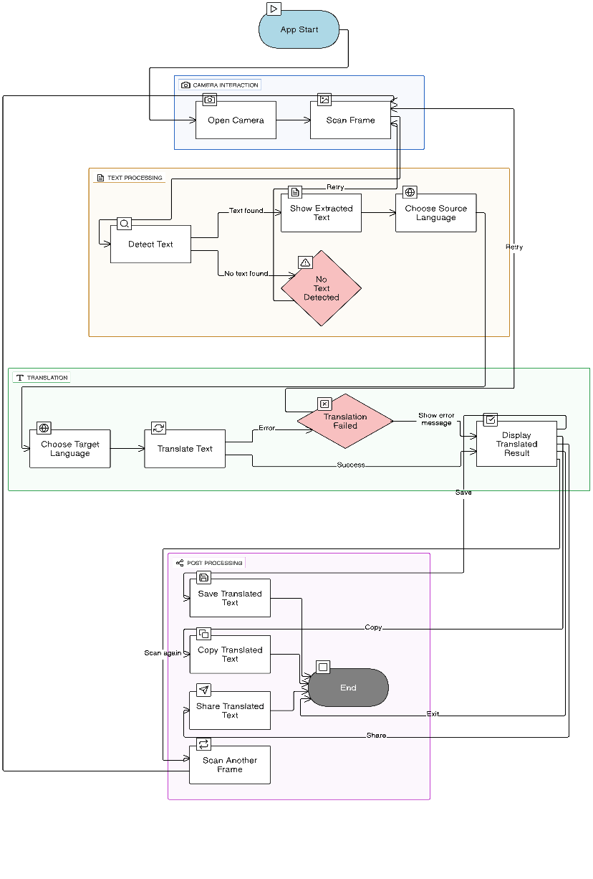
Figure 4.2: Sequence Diagram of Real-Time Text Extraction and Translation app

4.3. Activity Diagram:
The activity diagram shown in Figure 4.3 outlines the user interaction workflow in the system. The workflow begins with opening the app, setting preferred languages, and initiating the camera view. As users point the camera to text, the system performs OCR and then feeds the extracted text into the translation module. The output is shown in real-time, along with bounding boxes on the live preview. Users can also pause/resume translation, save results, or reset the session. This diagram highlights the decision points and user flows that define a seamless real-time experience.
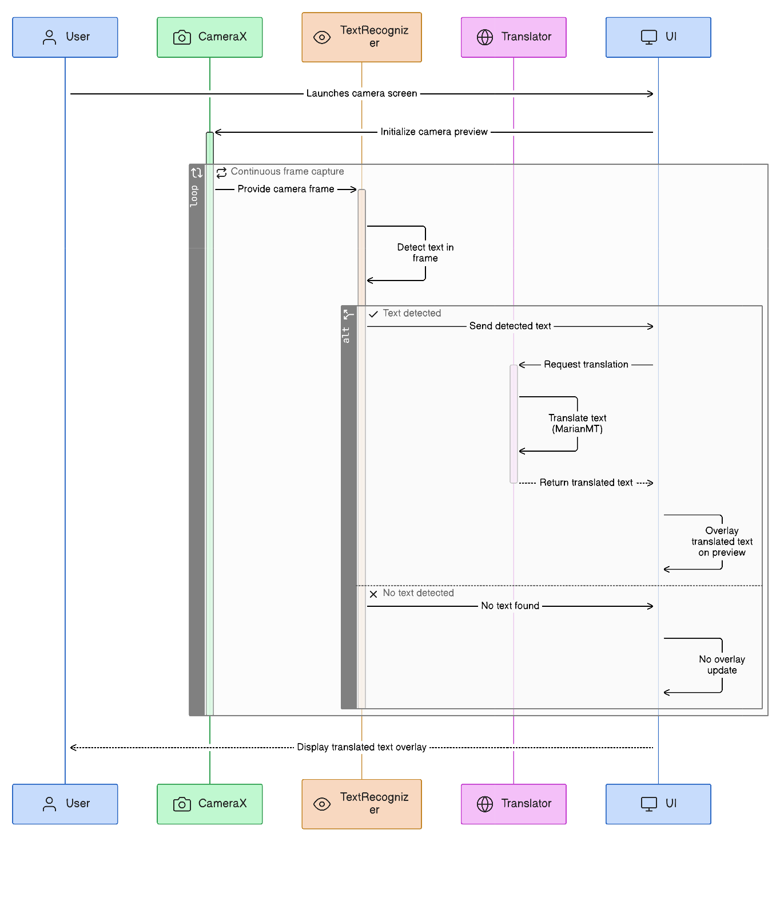
Figure 4.3: Activity Diagram of Real-Time Text Extraction and Translation app

4.4. Component Diagram:
The component diagram shown in Figure 4.4 illustrates the modular structure of the application. The system is divided into the following primary components: Camera Module, OCR, ModuleUI, LayerPreferences ManagerStorage Manager (optional), each component communicates via well-defined interfaces, ensuring flexibility and reusability. This architecture enables a clean separation between the logic for image processing, NLP tasks, and user interface.
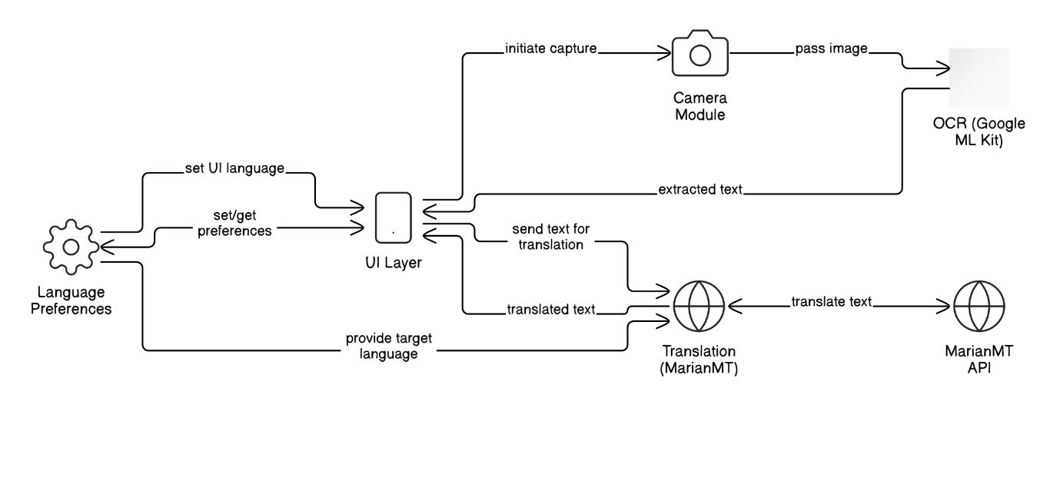
Figure 4.4: Component Diagram of Real-Time Text Extraction and Translation app

4.5. State Machine Diagram:
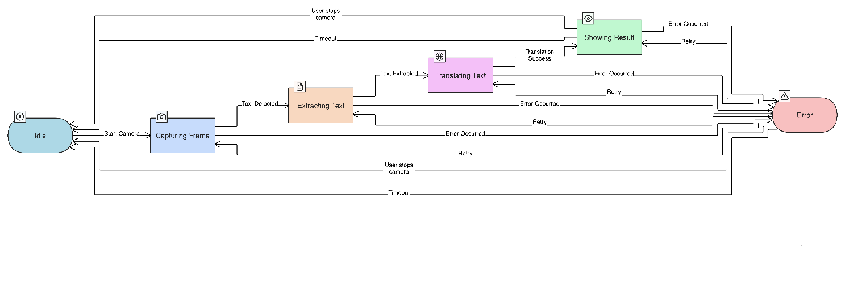
The state machine diagram shown in Figure 4.5 represents the different states the application can be in during runtime. These include Idle, Camera Active, Detection, Translation, Paused, Error State, terminated transitions between states are triggered by user actions (e.g., start, pause, stop) or system events (e.g., error, success), making the app behavior predictable and robust.
Figure 4.5: State Machine Diagram of Real-Time Text Extraction and Translation app

4.6. Application Architecture:

The application follows a MVVM (Model-View-ViewModel) architecture as shown in Figure 4.7 to maintain a clean separation between UI logic and business logic.Model Handles data classes like ExtractedText, TranslatedText, and manages user preferences, ViewModel Orchestrates OCR processing, translation, and UI state updates.View (UI) Built using Jetpack Compose, it observes the ViewModel and updates the UI in real-time based on live data changes. By leveraging Android Jetpack libraries, CameraX, and ML Kit, the application architecture is both modern and production-ready, designed for performance, testability, and future extensibility.
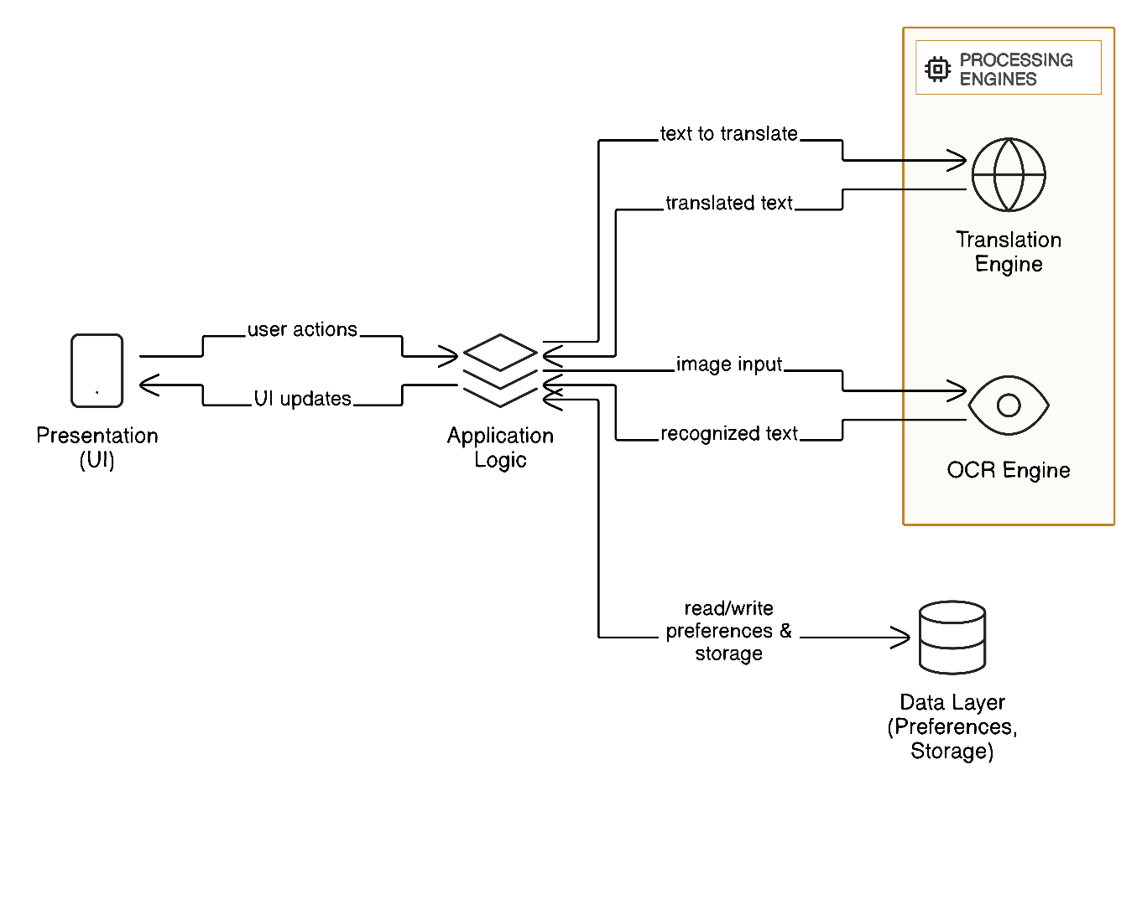
Figure 4.6: Application Architecture Diagram

Chapter 5: Implementation

This chapter explains the detailed implementation of the Real-Time Text Extraction and Translation on Android system. It focuses on the architectural design, component interactions, network and protocol decisions, middleware considerations, and the user interface structure. While the chapter describes how the system functions internally, it does not include any source code, in line with the requirements of the documentation.

5.1. Components
The component diagram presented earlier in Chapter 4 illustrated the core structural components of the system. This section further explains the implementation of each component and its role during system execution.

5.1.1. Camera Input Module (CameraX)
- Provides continuous live camera feed.
- Sends frames to the OCR Processing Module.

5.1.2. OCR Processing Module (Google ML Kit On-Device Text Recognition)
- Detects and extracts text regions from each frame.
- Outputs structured text (words, blocks, bounding boxes).
5.1.3. Translation Module (On-Device)
- Receives extracted text.
- Performs offline translation to the selected target language.
- Returns translated sentences in real-time.
5.1.4. Accessibility Layer (Voice Output + Haptic Feedback)
- Reads translated text aloud.
- Provides feedback for visually impaired users.
5.1.5. UI Layer (Jetpack Compose)
- Displays camera preview, bounding boxes, extracted text, translation output, and accessibility controls.
5.1.6. Storage Module (Room Database – Optional)
- Stores previously translated text.
- Supports history retrieval for offline usage.

Network and Protocol Choice
Although the system performs OCR and translation locally, minimal network communication may still be required for:

- Initial model downloading (mode), not bundled.
- Checking for language pack updates.
HTTPS (TLS-Encrypted REST Communication)
- Used for downloading translation models securely.
- Ensures privacy, integrity, and resistance to man-in-the-middle attacks.
Local (Offline) Communication
- OCR is fully offline.
- Translation is offline.
- Camera and UI are local.
Justification
- User privacy is preserved since sensitive data (captured text) is not sent to any servers.
- Performance improves as on-device models eliminate round-trip latency.
- Accessibility users benefit from stable offline operation in limited-connectivity environments.

Choice of Object Middleware
Although this project runs in a single process, Android’s IPC mechanism (Binder) underlies system operations such as:
- Communication between CameraX and UI
- Interaction with ML Kit services
- TTS engine communication
This design ensures efficient and secure local message passing without additional distributed system overhead.

User Interface
The User Interface is developed entirely using Jetpack Compose, providing a responsive and modern UI suitable for a real-time OCR environment

Chapter 6: Testing and Evaluation

This chapter discusses the testing strategies used to ensure the correctness, reliability, usability, and overall quality of the Real-Time Text Extraction and Translation on Android system. The testing process covered verification, validation, usability assessments, unit testing, integration testing, system-level testing, acceptance testing, and stress testing. Additionally, the chapter outlines the hardware configuration used during testing, followed by evaluation, deployment considerations, and maintenance plans.

Verification
Verification focused on confirming that the system was implemented according to its specified design and requirements. Throughout development, each component such as the camera module, OCR processor, translation engine, and user interface was reviewed to ensure it performed its intended function. Design documents, UML diagrams, and workflow descriptions were repeatedly cross-checked with the implemented modules to verify proper alignment. This process helped ensure that the software adhered to the planned architecture and satisfied all functional specifications before moving to broader testing phases.

Validation
Validation aimed to determine whether the system meets user needs and fulfills the objectives established at the beginning of the project. A series of real-world tests were conducted in different lighting conditions, using various text styles, languages, and background environments. The results demonstrated that the system accurately detected and translated text in real time while maintaining acceptable performance. In addition, validation involved feedback from potential users including individuals with visual impairments to ensure that accessibility features such as text-to-speech and haptic feedback performed as expected. This confirmed that the application was both functional and practical in real use cases.

Usability Testing
Usability testing focused on evaluating the ease of use, clarity, and overall user experience of the application. Test participants were asked to perform specific tasks such as scanning text, switching languages, enabling accessibility mode, and reviewing translation history. Their interactions were observed carefully to identify difficulties, misunderstandings, or unnecessary steps. The results showed that users were able to navigate the interface with minimal guidance, and most tasks were completed successfully within seconds. Improvements were made where needed—such as increasing button sizes, enhancing contrast, and simplifying navigation to ensure that users of all experience levels could interact with the app comfortably.

Module / Unit Testing
Unit testing was performed on individual modules to verify their correctness in isolation. Each major component, including the OCR analyzer, frame processor, translation handler, and UI state manager, was tested separately. Mock data was used to simulate typical scenarios, ensuring that each unit responded predictably. These tests helped identify boundary cases, error responses, and conditions where specific modules required optimization. By addressing defects early at the module level, the stability of the overall system significantly improved.

Integration Testing
Integration testing focused on ensuring that the individual modules worked correctly when combined. This phase involved linking the camera feed with the OCR engine, connecting OCR outputs with the translation module, and verifying the interaction between the translation results and the UI layer. During integration, edge cases such as rapid frame updates, inconsistent text detection, and sudden changes in lighting were examined. The results showed that the system handled these scenarios efficiently, without crashing or producing incorrect translations. This confirmed that the communication flow between components was stable and reliable.

System Testing
System testing evaluated the complete application as a unified entity. It covered end-to-end workflows, ensuring that the system performed consistently under realistic conditions. This included testing the real-time pipeline from camera input to OCR detection, translation, and presentation in the UI, as well as testing secondary features such as accessibility tools and history management. The system behaved as expected across various devices and environments, demonstrating that all requirements had been implemented successfully.

Acceptance Testing
Acceptance testing was performed to ensure the system met the expectations of stakeholders, teachers, and end users. Participants were given scenarios such as translating street signs, reading medicine labels, and assisting visually impaired individuals in understanding printed text. Feedback confirmed that the application delivered usable translations, operated smoothly on common Android devices, and fulfilled the project’s goal of enabling real-time text extraction and translation. After acceptance testing, the application was deemed ready for deployment.

Stress Testing
Stress testing evaluated how the system performs under high load or unfavorable conditions. The camera feed was exposed to rapid movements, cluttered backgrounds, extremely low lighting, and fast-changing scenes. Long-duration tests were conducted by running the application continuously for extended periods to detect memory leaks, overheating, or performance degradation. The app remained stable and responsive throughout, although battery drain increased during prolonged use due to continuous camera and ML processing. The system maintained acceptable performance even under heavy stress.

Hardware Configuration for Testing
Testing was conducted on multiple Android devices to ensure wide compatibility. The primary test device featured a mid-range processor (such as a Qualcomm Snapdragon series), 4–6 GB of RAM, and a 1080p display. Additional tests were performed on entry-level devices to evaluate performance under limited hardware capabilities. These configurations ensured that the application runs smoothly on typical devices available to most users. The camera supported autofocus and continuous frame streaming, both essential for accurate OCR performance.

Evaluation
Overall evaluation showed that the system performed efficiently in real-time scenarios. OCR accuracy remained high across various fonts, backgrounds, and lighting conditions. Translation performance was fast due to the on-device model, eliminating latency caused by network communication. Users appreciated the accessibility features, particularly the text-to-speech and haptic feedback mechanisms. The application met its intended objectives and delivered a reliable and inclusive user experience.

Deployment
The deployment phase involved preparing the application for distribution and installation. The app was packaged into an Android APK signed with a release keystore. Before deployment, the application was tested under Google Play guidelines, checked for security vulnerabilities, optimized for performance, and validated against Android compatibility requirements. The final build was ready for installation on any supported Android device, and its offline functionality ensured that users could rely on it without an internet connection.

Maintenance
Maintenance involves addressing bugs, improving performance, and updating models as needed. As machine learning models evolve, new language packs or improved translation models may be integrated into the system. Regular updates may also include UI enhancements, accessibility improvements, and compatibility updates for newer versions of Android. Maintenance ensures the application remains functional, secure, and aligned with user expectations over time.

Chapter 7: Conclusion and Future Work
This chapter presents the concluding remarks of the project Real-Time Text Extraction and Translation on Android, along with the potential areas of enhancement and future research directions.
  - Conclusion
- The project successfully achieved its goal of developing a real-time text extraction and translation system for Android devices using on-device machine learning technologies. By integrating CameraX, Google ML Kit OCR, and the MarianMT translation model, the application provides fast, private, and efficient text recognition without relying on network connectivity. This offline-first approach enhances performance, ensures user privacy, and enables accessibility in environments with limited or no internet access.
- Throughout development and testing, the system demonstrated high accuracy in detecting text from various surfaces, font styles, and lighting conditions. The inclusion of accessibility features such as text-to-speech, haptic feedback, and simplified UI elements ensured usability for visually impaired and physically challenged users, supporting the project’s core objective of inclusivity. The modular architecture, supported by modern Android development tools such as Jetpack Compose and Room Database, made the application maintainable, scalable, and responsive under real-world conditions.
- In summary, the project successfully delivered a functional, reliable, and user-friendly solution that bridges the gap between real-world printed text and digital translation, offering significant utility for everyday users, students, travelers, and visually impaired individuals. It stands as a valuable contribution to mobile accessibility technologies and real-time computational linguistics.

  - Future Work
- Although the project currently meets its defined objectives, several enhancements and extensions can significantly improve its capabilities in the future. One potential direction is the integration of multi-language simultaneous translation, enabling the application to detect and translate multiple languages within a single frame. This would be particularly useful in multilingual environments such as airports, markets, or official documents.
- Another promising area for future work is the addition of cloud-assisted translation as an optional feature. While the current system functions entirely offline, cloud-based models could provide more accurate translations for complex sentences, idioms, or low-resource languages. This optional hybrid mode could switch intelligently depending on the user’s connectivity.
- Future enhancements may also include the development of augmented reality (AR) overlay translation, where translated text is projected directly onto the original camera view as a visual replacement, similar to live AR subtitles. This would significantly improve user experience, especially when dealing with signage or printed instructions.
- Expanding support for voice commands and gesture-based navigation would make the application even more user-friendly for people with disabilities. Additionally, implementing handwriting recognition, support for mathematical notations, and document layout understanding would broaden the scope of the application’s use cases.
- The system can integrate more advanced neural models and optimize performance using TensorFlow Lite GPU acceleration, enabling faster and more sophisticated processing.
- Overall, the project provides a strong foundation for further research and development, with numerous possibilities to evolve into a fully intelligent, multi-modal translation assistant.

References
- Wu, Yonghui, et al. (2016). Google's Neural Machine Translation System: Bridging the Gap between Human and Machine Translation. arXiv preprint arXiv:1609.08144.
- Almeida, J. M., and Mota, M. F. (2020). Mobile OCR and Translation: Performance Analysis of Google Translate Instant Camera. Procedia Computer Science, 170, 864–869.
- Shi, Lei, et al. (2019). Towards an Inclusive Design: Accessibility Evaluation of Mobile Translation Applications for Visually Impaired Users. ACM SIGACCESS Accessibility and Computing, (124), 3–10.
- Tiedemann, J., and Thottingal, S. (2020). OPUS-MT — Building open translation services for the World. EAMT 2020.
- Wu, J., Chen, T., and Lin, Y. (2022). Lightweight On-device Translation: Performance and Limitations in Mobile Environments. Journal of Mobile Computing, 11(2), 45–52.

